Practice on Quantum Numbers
- Answer the following:
- How many orbitals in the l = 1 subshell?

- What is the maximum number of electrons in a d subshell?

- What is the subshell designation when n = 3 and l = 2?

- How many subshells in the n = 4 shell?

- Briefly explain what the term degeneracy means when used to describe features of the energy level diagram for a multi-electron atom.

- Briefly describe the difference between an orbit and an orbital as it relates to an electron in a hydrogen atom.

- Sketch the orbital diagram for the valence electrons in copper.

- Write the short hand electron configuration for each of the following.
a) Cu [
b) Ca²⁺
c) Po
d) Se²⁻
e) Ir
- Write the possible set of quantum numbers for all valence electron in an antimony (Sb) atom in its ground state.

- Given the five orbital diagrams labeled A, B, C, D, and E.
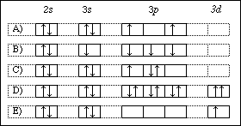
From the orbital diagrams select an example which demonstrates
i). a violation of Hund's rule
ii). a violation of the Pauli exclusion principle
iii). a ground state orbital diagram
iv). an excited state orbital diagram
v). a violation of the Aufbau principle

